# § 1 – Population ageing and dejuvenation

G-Numbers: G109, 110, 111, 112, 115

# § 2 – Help population ageing!

G-numbers: G112, 150, 151, 156

# § 3 – Mobility

G-numbers: G143, 149

# § 1 Population ageing and dejuvenation

* **Less younger people**
* Every year population grows in NL, by migration and a pos. birth surplus.
* The fertility rate has shrinked, in past 4 children per household now only on 1.7. Wich should be 2.1 to keep population same size. Furthermore wives also become mother at a late age (29 years).
* This is caused by: Contraceptive is invented, and church doesn’t obligate you to have children.
* Population dejuvenation is happening: the 0-19 group becomes smaller
* **More elderly people**
* There are more elderly people, this is caused by:
* Less children are born 🡪 this make elderly group bigger (relative)
* Because of the baby-boom after WWII, today more elderly are there. (Sixty year ago a lot of young people born, they are now old)
* The life expectancy has increased
* **Demographic pressure**
* NL will have a population shrinkage in the near future. Because of the more elderly and less youngster (high grey pressure). Migration won’t make this no. up

# § 2 Help population ageing!

* **Stop population ageing**
* Dejuvenation could be increased, to slow down ageing, the government could encourage people to have children, but this won’t have because of small families. (~~solution~~)
* Mass immigration could stop ageing for a short time, because a lot of youngster will immigrate. This will also cause a lot of children to be born. BUT no good solution because NL is already crowded. And it’s only temporary.
* Positive side of ageing, is that jobs will occur (nurses, scooters etc.). And can’t elderly work longer, life expectancy is already higher.
* **Regional differences**
* After 2038, population shrinkage will start. But only in the western part. In the rest it will keep growing. Youngster will also go to the Randstand because work can be found there.
* If places will become empty you could demolish houses and build bigger and larger in place.

# § 3 Mobility

* **More traffic**
* Mobility has increased, because of suburbanization which caused commuter traffic. There are more holidays and wealth caused more cars. Longer distances became normal.
* **Consequences**
* Consequences of increased car traffic are:
  + **Fragmentation:** More motorways are build 🡪 nature areas were split up, animals disappeared.
  + **Environment:** Pollution🡪 too much, no houses can be build
  + **Economy:** Traffic jams 🡪 costs a lot, for companies but also government
* **Solutions**
* NEN, makes sure there is less fragmentation and makes new nature
* Less pollution, because of environmental friendly cars. But still CO2, as long as mobility increases
* Noise pollution is also reduced because of quieter cars and roads.

# G109 Changes in population size

* Natural changes 🡪 birth/death surplus, together natural population growth
* Migration (not within town) 🡪 immigration/emigration surplus, together net migration rate

# G110 Population figures: absolute and relative

* 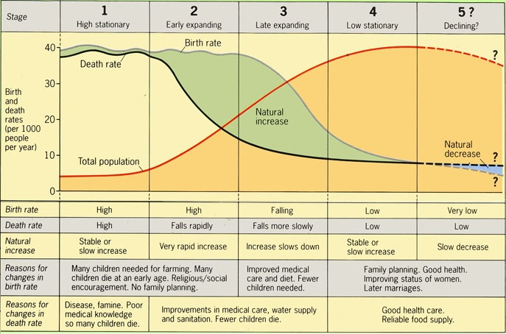Absolute numbers: real
* Relative numbers: % or ‰
* Birth/death rate = no. Of born/death per 1000 inhab.

# G111 Demographic figures

* Demography = study of no. Of people and change in them
* Demographic transition = long-term changes in population size (only natural)
* Demographic transition model 🡪

# G112 Population chart

* The population chart shows the age structure per country. Male and female separated

# G115 Demographic pressure

* Youth (0-19); Producers (20-65); Elderly (>65)
* Demographic pressure = producers have to earn more to support other groups, (because of ageing), you can have green and grey pressure.

$\frac{number of 0-19 years+number of 65+}{number of 20-65 years}*100\%=demographic pressure$

# G150 Urban renewal

* Urban renewal = Improvement of old houses
  + Demolition and new building
  + Renovation = building function doesn’t change
  + Restoration = buildings function does change
* Vogelaarwijken = problem wijken, named of minister Vogelaar

# G151 Housing density and household size

* Household size is smaller, because you families are smaller
* Housing density = no. Of houses per km2

# G156 Ghettos

* At first, place for Jews, latter for different poor neighbourhoods
* Problem / deprived neighbourhoods, have a lot of problems
* Neighbourhoods will be renewed (better name), ways to change hood:
  + Police
  + Sport clubs
  + 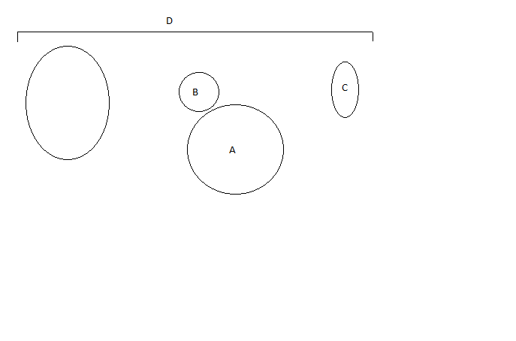Language courses

# G143 Conurbations

* A Main city
* A+B Agglomeration   
  *(city overflowing in surroundings)*
* A+B+C Urban region (Network city),   
  *(all towns depending on the main city)*
* D Conurbation   
  *(2 urban regions melted together)*
* Megalopis: 2 conurbations melted together (boswash)
* Metropolis: enormous agglomeration (Tokyo)

# G149 Commuting and mobility

* Commuters: people travelling in between towns for work, (travel between urban region)
* Mobility = possibility to move (by car: auto mobility)
* This causes traffic jams